**USER Structure & relationships**

**USER**



Staff USER

Teacher USER

Student USER

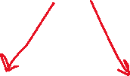

Staff User

Emp Profile

Teacher User

Student Profile